DALLAS BY DEFINITION
511 E. JOHN W. CARPENTER FRWY.
SUITE 100
IRVING, TX 75062
972-869-2366 / 1-800-336-1417
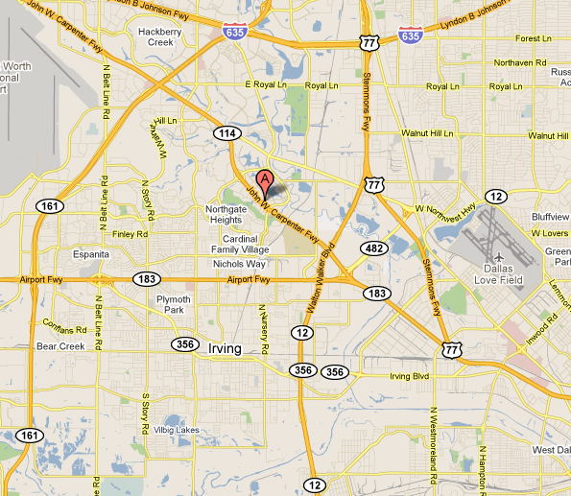

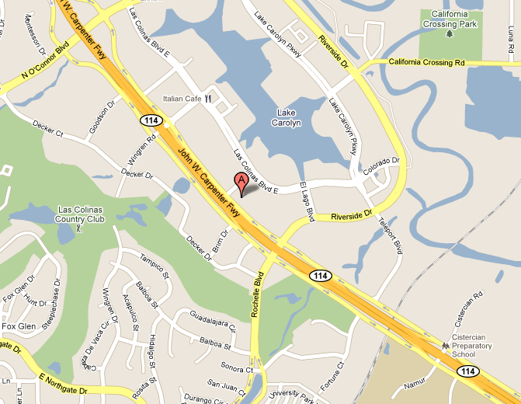
Directions:
From the South: (Grand Prairie, Cedar Hill)
Follow Loop 12 North to Hwy 114. Take Hwy 114 WEST. Stay on Hwy 114 for a short distance. Take the Rochelle Blvd / Riverside Dr exit. Remain on the access road and go straight through the traffic light at Riverside Dr to 511 E. John W. Carpenter Fwy. The building is on your right.
To Park: Go past building to Brazos St and turn right, then take immediate right to underground parking. Please DO NOT PARK IN RESERVED PARKING AREAS. Vehicles parked in a spot marked “Reserved” may be towed. We are located on the lobby level in Suite 100.

From the West: (North of DFW Airport)
Take Hwy 114 East. Stay on Hwy 114 approximately 10 miles from airport to the Rochelle Blvd / Riverside Dr exit. Turn left over Hwy 114 and turn left onto the access road going west. Remain on the access road, to 511 E John W. Carpenter Fwy. The building is on your right.
To Park: Go past building to Brazos St and turn right, then take immediate right to underground parking. Please DO NOT PARK IN RESERVED PARKING AREAS. Vehicles parked in a spot marked “Reserved” may be towed. We are located on the lobby level in Suite 100.

From the West: (South of DFW Airport, HEB, and Arlington Area)
Take 183 East for approximately 7 miles from DFW Airport to the O’Connor Rd exit. Turn left onto O’Connor Rd. Follow O’Connor until you reach Hwy 114 (approximately 3 miles). Turn right onto Hwy 114. Go to the Rochelle Blvd / Riverside Dr exit and turn left over Hwy 114 and immediate left again onto access road heading west. Dallas By Definition is the second building on the right, 511 E. John W. Carpenter Frwy.
To Park: Go past building to Brazos St and turn right, then take immediate right to underground parking. Please DO NOT PARK IN RESERVED PARKING AREAS. Vehicles parked in a spot marked “Reserved” may be towed. We are located on the lobby level in Suite 100.

From the East: (Downtown Area)
Take I35 North to Hwy 183 West (Airport Freeway). Take Hwy 114 West toward Grapevine. Remain on Hwy 114 past Loop 12. Take the Riverside Drive / Rochelle Blvd exit. Drive straight at the traffic light at Riverside Dr (remain on the service road). Dallas By Definition is the second building on the right, 511 E. John W. Carpenter Frwy.
To Park: Go past building to Brazos St and turn right, then take immediate right to underground parking. Please DO NOT PARK IN RESERVED PARKING AREAS. Vehicles parked in a spot marked “Reserved” may be towed. We are located on the lobby level in Suite 100.

From the North: (North Dallas)
Take I-35 South to Loop 12 South. Follow Loop 12 South to the Hwy 114 exit. Take the access road for Hwy 114 West. Remain on the access road to Rochelle / Riverside. Drive past light at Rochelle/Riverside, to 511 E. John W. Carpenter Frwy on right. To Park: Go past building to Brazos St and turn right, then take immediate right to underground parking. Please DO NOT PARK IN RESERVED PARKING AREAS. Vehicles parked in a spot marked “Reserved” may be towed. We are located on the Lobby Level in suite 100.

